(Link the banner to the website) 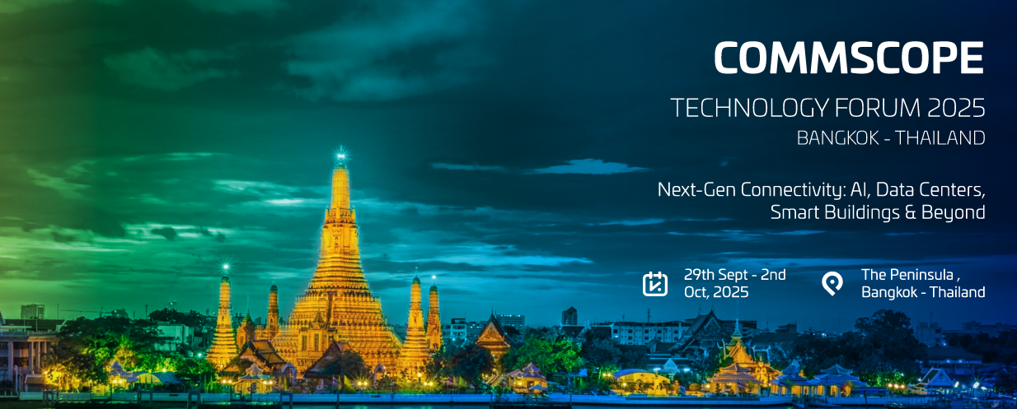

|  |  |  |  |  |  |  |  |  |  |  |  |  |
| --- | --- | --- | --- | --- | --- | --- | --- | --- | --- | --- | --- | --- |
| |  | | --- | |  | | |  |  |  |  |  |  |  |  |  | | --- | --- | --- | --- | --- | --- | --- | --- | --- | | Dear Valued Customer,  From AI and hyperscale data centres to smart buildings and connected cities—next-gen connectivity is redefining how we live, work, and innovate.  CommScope is pleased to invite you to the **CommScope Technology Forum 2025** taking place from 29th September to 2nd October 2025 at [The Peninsula, Bangkok, Thailand](https://www.peninsula.com/en/bangkok/5-star-luxury-hotel-riverside).  Join industry leaders, innovators, and technology experts for an unforgettable experience in one of Asia’s most vibrant cities.  With the theme: Next-Gen Connectivity: AI, Data Centres, Smart Buildings & Beyond, this forum will showcase cutting-edge innovations that are transforming global infrastructure and powering the digital future. At the Forum, you’ll gain exclusive insights into:  •**AI-powered** infrastructure redefining connectivity and automation.  **•Future-ready data centres** built to scale with tomorrow’s demands.  •**Smart building technologies** enabling greener, more efficient environments.  •**The next wave of innovation**—edge computing, 5G, IoT, and more.  **This invite-only event is more than a conference**—it’s a chance to connect, collaborate, and explore new opportunities with peers and experts from across the MEA region. Please note that this is a professional, non-spouse program.  We’re proud to be your trusted partner, and we look forward to sharing CommScope’s latest breakthroughs in a truly inspiring setting.  🎯 **Seats are limited—mark your calendar and register today!**  Registration Button  **We look forward to welcoming you to Bangkok.**  **Best Regards,** CommScope Team |  | |  |  | | --- | --- | | [Calendar Icon](https://ik.imagekit.io/ixtx5enruw/Save%20the%20Date%20-%20CommScope%20Technology%20Forum%202025.ics?updatedAt=1755079635944) | [29th Sept - 2nd Oct, 2025](https://ik.imagekit.io/ixtx5enruw/Save%20the%20Date%20-%20CommScope%20Technology%20Forum%202025.ics?updatedAt=1755079635944) | |  |  |  |  |  | | --- | --- | | Location Icon | [The Peninsula - Bangkok, Thailand](https://www.peninsula.com/en/bangkok/5-star-luxury-hotel-riverside) |   Registration Button  **AGENDA**  **29th Sept**   * Arrival * Dinner at Peninsula Hotel   **30th Sept**  • Full Day Conference  • Evening Dinner Cruise  **1st Oct**  • Grand Palace Tour  • Lunch at the restaurant  **2nd Oct**   * Breakfast * Check out and Departure   **For more information, please contact:** [commscope@msdplus.com](mailto:commscope@msdplus.com) | | | [CommScope Footer](https://www.commscope.com/) | |